Table of Contents

ABSTRACT 2

CHAPTER 1 – INTRODUCTION 3

1.1 Scope of the Project 5

1.2. System Specifications 5

2.1Existing Definition: 6

2.2 Proposed Solution: 7

CHAPTER 3 OVERALL DESCRIPTION OF THE PROPOSED SYSTEM 8

3.1 Product Perspective 8

3.2 System Features 8

CHAPTER 4 – DESIGN 13

4.1UML Diagrams: 14

4.1.1Usecase Diagrams: 14

4.1.2 Sequence Diagram: 17

4.1.3 CLASS DIAGRAM 18

4.1.4 DATABASE DESIGN. 20

CHAPTER 5 - OUTPUT SCREENSHOTS 30

CHAPTER 6 – IMPLEMENTATION DETAILS 30

6.1 Introduction to Html Framework 30

6.2 Cascading Style Sheets (CSS) 31

6.3 MYSQL Server 33

6.4PHP 33

6.5 ANGULAR JAVA SCRIPT 34

CHAPTER 7-SYSTEM STUDY 35

CHAPTER 8-NON FUNCTIONAL REQUIERMENTS 37

CHAPTER 9- SYSTEM TESTING 39

CHAPTER 10– CONCLUSIONS 44

CHAPTER 11- REFERENCES 45

**Cruise Ship Management Application**

# ABSTRACT

Cruise ship facility depends on voyagers only. When one ship during voyage time voyages requirements are ordering through walkie-talkie or telephone. This method or device had any problem occur means voyages have to go and directly buy their requirements in several department. So this system enhanced voyages order items through online. Each voyager has unique Id and Password. So, voyager login this system they can order their requirements. Voyagers can order catering items and stationary items through this system. And they can book Resort-Movie tickets, Beauty Saloon, Fitness Center and Party Hall. [**Cruise Ship Management Mobile App**](https://codeshoppy.com/shop/product/cruise-ship-management/)Catering items order means voyager can order snacks items, food items, drinks items and so on. A stationary items order means they can order gift items, candy items, and story books and so on. Tickets booking means they have to select movie and check availability for seating allotments finally booking their tickets. Resort booking means voyager select type of restaurant. There are several types ocean view, balcony view, corridor view and lounge booking. Fitness center booking means they have to select their exercise equipment through this system. And they can also book their gym work timing. Party hall booking facilities available in this system. Here also type of halls is their voyager have to select their require hall. There are birthday parties, marriage party, engagement party, business party, get-to-gather parties and so on. Head-cook view catering items and passing order to deliver that item to several department. Supervisor view stationary items and passing order to deliver that item to several departments.

# CHAPTER 1 – INTRODUCTION

The Cruise Materials Management System (CMMS) offers the ship operator a complete tool to manage the purchasing and inventory control processes in an efficient, time and cost saving manner. The program follows the logical purchasing process from time of purchase to the point of consumption and is fully integrated with the Cruise Ship’s Property Management System (SPMS). This program can be used in a shore side location, at a cruise operator’s Head Office (the Head Quarter Module) if they are responsible for the purchasing process for the vessel or fleet of vessels or onboard a ship (Shipside Module) if the ship is directly responsible for the purchasing task. Customers for CMMS are the existing Cruise customers who have been using the original Cruise product& Beverage system but as this program is also a stand-alone product - it can be used independently of the Cruise SPMS - non-Cruise customers are potential customers. In addition to offering full integration with the Cruise SPMS and an on-line interface to the Point of Sale system, one of the key benefits of CMMS is that it gives the user a total overview (historic and real time) of all consumables. The user can track and check on the status of all food, beverage, uniforms, tools, shop stock, medical items and more, that have been ordered, purchased, delivered, consumed and invoiced throughout the life cycle of that item.

**Features of the System:**

Cruise ship facility depends on voyagers only. When one ship during voyage time voyages requirements are ordering through walkie-talkie or telephone. This method or device had any problem occur means voyages have to go and directly buy their requirements in several department.

Manager view all the booking items. If voyager booking or ordering items on the time tickets are not available means “Ordering or Booking items are currently not available” message will be displayed in this system. Admin maintain menu items for this system. Admin can insert, update and delete for menu items. Then admin only allocate voyager registration details.

So admin use these details and create login id and password for voyages. Then admin can provide login Id and Password. So this system enhanced voyages order items through online. Each voyager has unique Id and Password. So, voyager login this system they can order their requirements. Voyagers can order catering items and stationary items through this system. And they can book Resort-Movie tickets, Beauty Saloon, Fitness Centre and Party Hall. Catering items order means voyager can order snacks items, food items, drinks items and so on. A stationary items order means they can order gift items, candy items, and story books and so on. Movie tickets booking means they have to select movie and check availability for seating allotments finally booking their tickets. Resort booking means voyager select type of restaurant. There are several types ocean view, balcony view, corridor view and lounge booking. Fitness centre booking means they have to select their exercise equipment through this system. And they can also book their gym work timing. Party hall booking facilities available in this system. Here also type of halls is their voyager have to select their require hall. There are birthday parties, marriage party, engagement party, business party, get-to-gather parties and so on. Head-cook view catering items and passing order to deliver that item to several department. Supervisor view stationary items and passing order to deliver that item to several departments. To understand that every client, every ship, every itinerary and every product is unique. Therefore, the greatest advantage Cruise Management International brings is a genuine confidence that technical management team is fully engaged, immensely experienced and exceptionally driven to meet your specific needs. More importantly, CMI embraces your business with a personalized approach to cruise ship management, and a customer service level.

## Scope of the Project

The objective of the application is to streamline the process for creating inventories of both main stores and points of consumption by giving the user the ability to enter inventory data directly into a handheld device instead of using printed count sheets. The data entered into the mobile device will then be uploaded to the database via a web service interface. In addition to processing inventories, the mobile application also includes functionality to allow the user to view, control and enter exact amounts received from suppliers during loading

## 1.2. System Specifications

**Hardware Requirements**

Windows Desktop

* System   :  Intel3core
* HardDisk  :  8GB
* Monitor  :  14’ColorMonitor
* Mouse            :   Optical Mouse

**Software Requirements**

* Front End: HTML5, CSS3, Bootstrap
* Back End: PHP, MYSQL
* Control End: Angular Java Script

**Tools:**

* Android Emulator
* Xampp-win32-5.5.19-0-VC11
* Android SDK – adt-bundle-windows-x86
* IDE: Eclipse Mars
* Jdk-8u66-windows-i586

## 2.1Existing Definition:

This project is associated to maintain Ship details, Shipment details, Stock details and work order details these details are going to be maintained in manual process to do All these tasks it will take lot of time. Thus the existing system not supporting multi-user support. It is having lots of manual work (Manual system does not mean that you are working with pen and paper, it also include working on spread sheets and other simple software's).

**Drawbacks of the system:**

* The existing is an undeveloped form and the manual process of the overall system is too clumsy and complicated.
* The Customers facing lot of problems to know their c schedule details.
* It is very difficult to know Employee work order details.
* It is very difficult to know the stock details and available status immediately.
* The present system is very less secure.
* It is unable to generate different kinds of report.
* It is difficult to maintain Phones.
* Manual Interaction of Friends is much difficult.

## 2.2 Proposed Solution:

This product interacts with mainly three entities i.e. Customer, Employee and Stores Department. The automated system with distributed architecture can support issues like the system maintains the details of all types of ship details. The system intemperate consistently all projects and sub contacts into one canted storage with proper association. The details about the shipment to Customer maintained very fast in a short period of time. All the Ship details, work order details, Customer details are segregated and stored consistently with unique Ids.

**ADVANTAGES**

The system makes the overall project management much easier and flexible.

* The schedule of the presently working Employee on various ships with the details of their status is maintained.
* There is no risk of data mismanagement at any level while the project development is under process.
* The Optima Cruise Management Software is the complete, leading, most advanced system for the cruise ships industry Cruise Management system.
* Synchronized online and telephonic boat reservation system would increases your reservations.
* It provides integrated hospitality technology for the cruise line industry that automates operations such as collecting our systems.

# CHAPTER 3 OVERALL DESCRIPTION OF THE PROPOSED SYSTEM

## 3.1 Product Perspective

Manager view all the booking items. If voyager booking or ordering items on the time tickets are not available means “Ordering or Booking items are currently not available” message will be displayed in this system. Admin maintain menu items for this system. Admin can insert, update and delete for menu items. Then admin only allocate voyager registration details. So admin use these details and create login id and password for voyages. Then admin can provide login Id and Password. So this system enhanced voyages order items through online. Each voyager has unique Id and Password. So, voyager login this system they can order their requirements. Voyagers can order catering items and stationary items through this system. And they can book Resort-Movie tickets, Beauty Saloon, Fitness Centre and Party Hall

## 3.2 System Features

In the life of the software development, problem analysis provides a base for design and development phase. The problem is analyzed so that sufficient matter is provided to design a new system.

Large problems are sub-divided into smaller once to make them understandable and easy for finding solutions. Same in this project all the task are sub-divided and categorized.

**System Modules:**

1. **Voyager**
2. **Admin**
3. **Manager**
4. **Head-Cook**
5. **Supervisor**
6. **User**

**1. VOYAGER**

* User name and password
* Sign In
* Ordering catering items
* Ordering stationary items
* Booking Resort-Movie tickets
* Booking beauty salon
* Booking fitness centre
* Booking party hall

**2. ADMIN**

* User name and password
* Sign In
* Add Item
* Edit/ Delete Item
* Maintain menu items
* Voyager registration

**3. MANAGER**

* View booked Resort- Movie Tickets
* View booked beauty salon
* View booked fitness centre
* View booked fitness centre
* View booked Party hall

**4. HEAD-COOK**

* View ordered catering items

**5. SUPERVISOR**

* View ordered stationary items

**3.3.1 Sign Up**

The main activities in the application are the user login page for user. The other modules are followed by this login page. This module records only user and password of the user.

**3.3.2 Voyager**

Itdepends on voyagers only. When one ship during voyage time voyages requirements are ordering through walkie-talkie or telephone. This method or device had any problem occur means voyages have to go and directly buy their requirements in several department. So this system enhanced voyages order items through online. Each voyager has unique Id and Password. So, voyager login this system they can order their requirements. Voyagers can order catering items and stationary items through this system. And they can book Resort-Movie tickets, Beauty Saloon, Fitness Centre and Party Hall. Catering items order means voyager can order snacks items, food items, drinks items and so on. A stationary items order means they can order gift items, candy items, and story books and so on. Movie tickets booking means they have to select movie and check availability for seating allotments finally booking their tickets. Resort booking means voyager select type of restaurant.

**3.3.3** **Admin**

Admin maintain menu items for this system. Admin can insert, update and delete for menu items. Then admin only allocate voyager registration details. So admin use these details and create login id and password for voyages. Then admin can provide login Id and Password.

**3.3.4 Manager**

Manager view all the booking items. If voyager booking or ordering items on the time tickets are not available means “Ordering or Booking items are currently not available” message will be displayed in this system.

**3.3.5 Head-Cook**

Head-cook view catering items and passing order to deliver that item to several department. Supervisor view stationary items and passing order to deliver that item to several departments.

**3.3.6 Supervisor**

Supervisor view all the stationary items. If customer booking or ordering items on the time are not available means “Ordering or Stationary items are currently not available” message will be displayed in this system.

**3.3.6 User**

User wants to register all details after that only sign in that page. This module records only user and password of the user. After sign in the page it shows Catering and Categories. To select our need and purchase all those products. There are several types ocean view, balcony view, corridor view and lounge booking. Fitness centre booking means they have to select their exercise equipment through this system. And they can also book their gym work timing. Party hall booking facilities available in this system. Here also type of halls is their voyager have to select their require hall. There are birthday parties, marriage party, engagement party, business party, get-to-gather parties

# CHAPTER 4 – DESIGN

Design is the first step in the development phase for any techniques and principles for the purpose of defining a device, a process or system in sufficient detail to permit its physical realization.

Once the software requirements have been analyzed and specified the software design involves three technical activities - design, coding, implementation and testing that are required to build and verify the software.

The design activities are of main importance in this phase, because in this activity, decisions ultimately affecting the success of the software implementation and its ease of maintenance are made. These decisions have the final bearing upon reliability and maintainability of the system. Design is the only way to accurately translate the customer’s requirements into finished software or a system.

Design is the place where quality is fostered in development. Software design is a process through which requirements are translated into a representation of software. Software design is conducted in two steps. Preliminary design is concerned with the transformation of requirements into data.

## 4.1UML Diagrams:

UML stands for Unified Modeling Language. UML is a language for specifying, visualizing and documenting the system. This is the step while developing any product after analysis. The goal from this is to produce a model of the entities involved in the project which later need to be built. The representation of the entities that are to be used in the product being developed need to be designed.

There are various kinds of methods in software design:

* Use case Diagram
* Sequence Diagram
* Class Diagram

### 4.1.1Usecase Diagrams:

Use case diagrams model behavior within a system and helps the developers understand of what the user require. The stick man represents what’s called an actor. Use case diagram can be useful for getting an overall view of the system and clarifying who can do and more importantly what they can’t do.

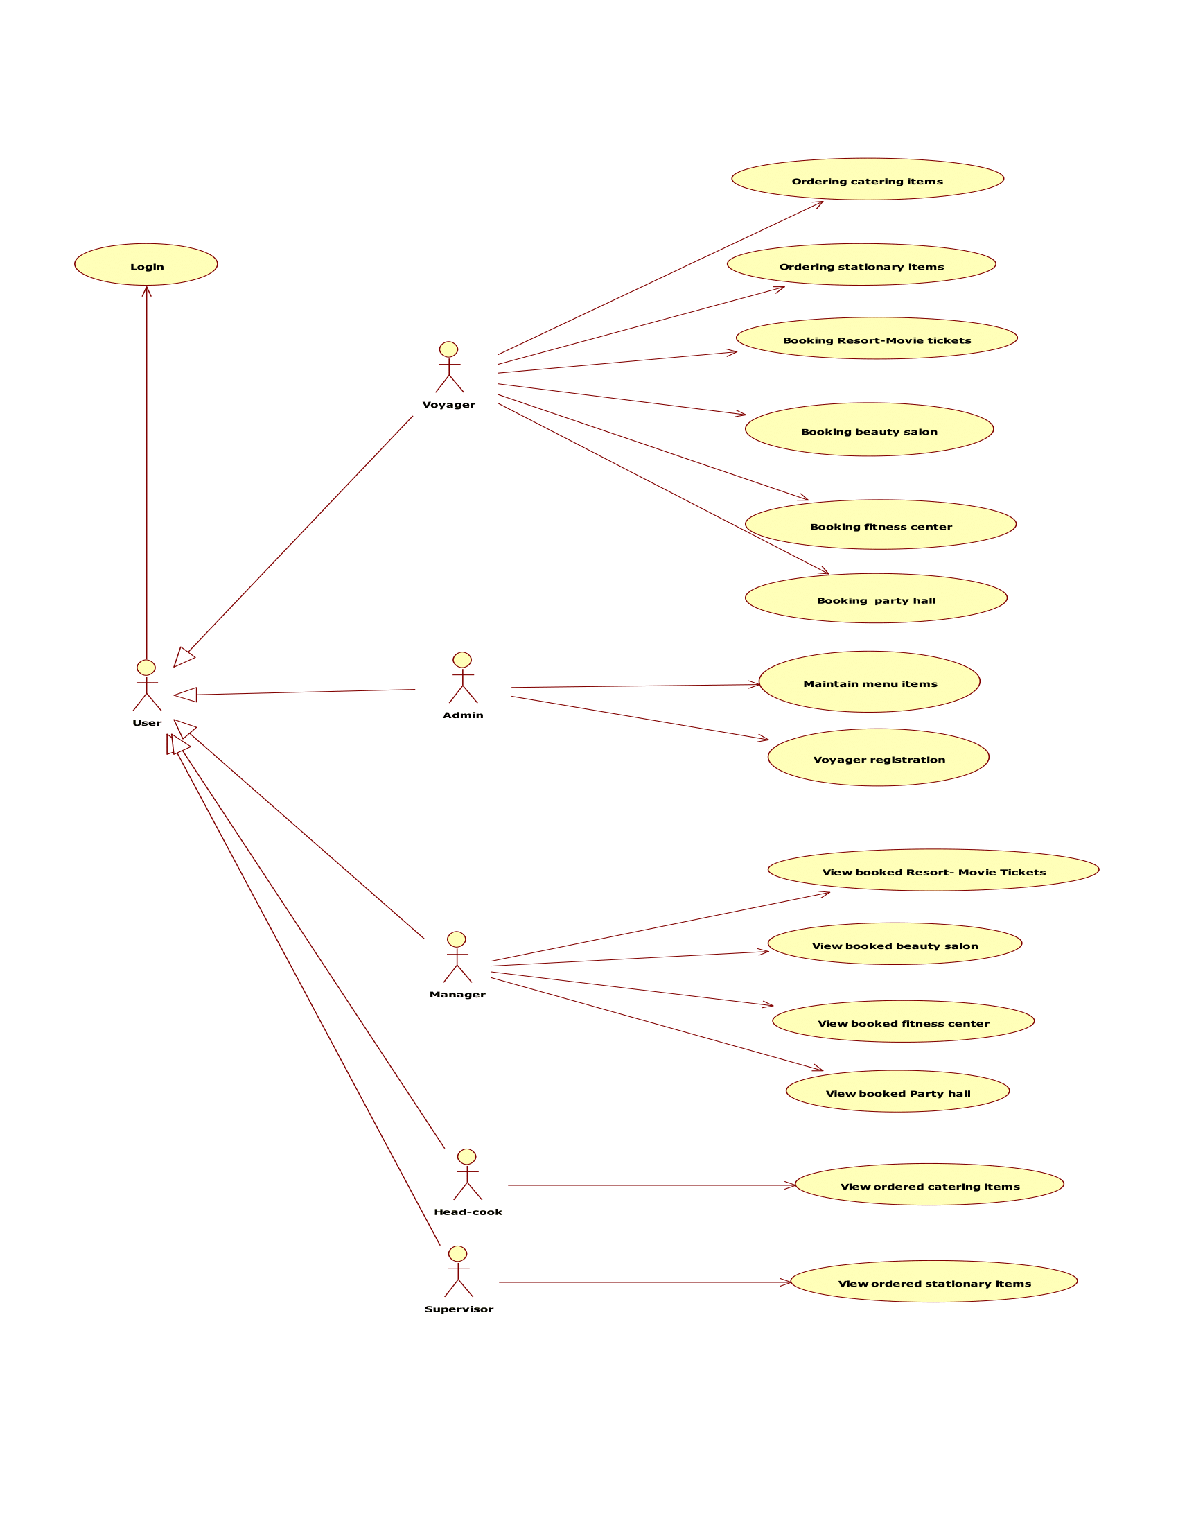

1. **Use Case Description <Login>**
2. **1 Brief Description**

The Use case describes how the user and voyager login the Cruise Ship Voyager Facility System.

**1.2 Flow Of Events**

**1.2.1 Basic flow**

**1.2.1.2** When a user and voyager login the Cruise ShipVoyager Facility system this use case helps.**1.2.1.3** The system prompts the actors to enter usernameand password.**1.2.1.4** The actors should specify the name andpassword while entering the system. The system validates the name and password and permits the actors to access the system.

**1.3** **Alternative Flow**

**1.3.1** **<Invalid Username>**

When they entered username is invalid then the systems display an error message. The system informs the actors to either cancel (or) re-enter the username.

**1.3.2. < Invalid Password>**

When they entered password is invalid then the systems display an error message**.** The system informs the actors to either cancel (or) re-enter the password.

**1.4. Special Requirements**

None.

**1.5. Pre-Condition**

The user will be provided with unique username and password after the successful registration.

**1.6. Post condition**

Once the registration is done, the user can login the system.

**1.7. Extension Points**

None.

Use case diagram consists of use cases and actors and shows the interaction between the use case and actors.

* The purpose is to show the interactions between the use case and actor.
* To represent the system requirements from user’s perspective.
* An actor could be the end-user of the system or an external system.

### 4.1.2 Sequence Diagram:

Sequence diagram and collaboration diagram are called INTERACTION DIAGRAMS. An interaction diagram shows an interaction, consisting of set of objects and their relationship including the messages that may be dispatched among them.

A sequence diagram is an introduction that empathizes the time ordering of messages. Graphically a sequence diagram is a table that shows objects arranged along the X-axis and messages ordered in increasing time along the Y-axis.

Admin

User

Database

1 :Voyger register and login()

2 : user register and login()

3 : update details()

4 : view availability()

### 4.1.3 CLASS DIAGRAM

A class diagram is an illustration of the relationships and [source code](https://searchmicroservices.techtarget.com/definition/source-code) dependencies among classes in the Unified Modeling Language (UML). In this context, a [class](https://whatis.techtarget.com/definition/class) defines the [method](https://whatis.techtarget.com/definition/method)s and [variable](https://whatis.techtarget.com/definition/variable)s in an [object](https://searchmicroservices.techtarget.com/definition/object), which is a specific entity in a program or the unit of code representing that entity. Class diagrams are useful in all forms of object-oriented programming (OOP). The concept is several years old but has been refined as OOP modeling paradigms have evolved.

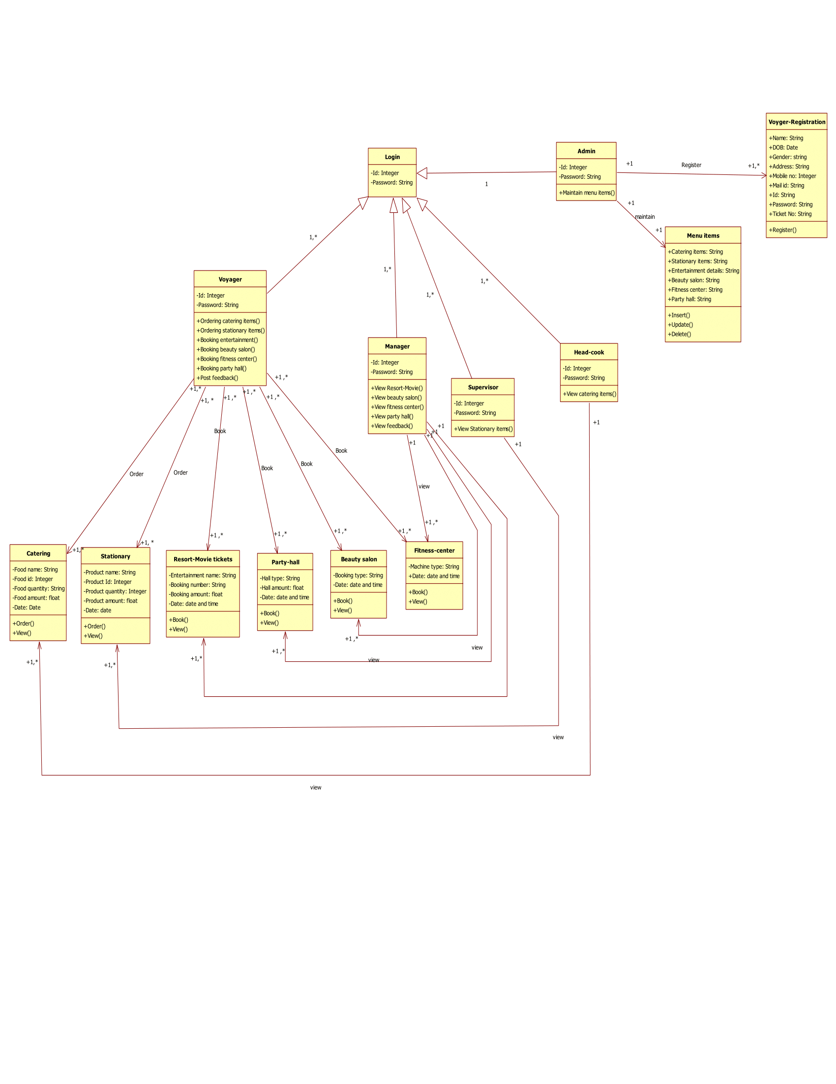

### 4.1.4 DATABASE DESIGN.

**4.1 VOYAGER_REGISTEARATION:**

|  |  |  |  |  |  |
| --- | --- | --- | --- | --- | --- |
| S.NO | FIELD | DATA | SIZE | CONSTRAINTS | DESCRIPTION |
|  |  | TYPE |  |  |  |
| 1 | Name | Varchar | 20 | Not Null | Specifies name of the |
|  |  |  |  |  | user |
| 2 | Address | Varchar | 50 | Not Null | Own address of the |
|  |  |  |  |  | user |
| 3 | Pin code | Numeric | 6 | Not Null | Specifies the postal |
|  |  |  |  |  | number |
| 4 | DOB | Numeric | 8 | Not Null | Specifies the DOB |
| 5 | Mobile no | Numeric | 10 | Not Null | Specifies the mobile |
|  |  |  |  |  | no |
| 6 | email | Varchar | 25 | Not Null | Email id of the user |
| 7 | User id | Varchar | 20 | Primary key | Specifies unique id of |
|  |  |  |  |  | the user |
| 8 | password | Varchar | 20 | Not Null | Security code of the |
|  |  |  |  |  | user |
| 9 | Ticket no | Varchar | 20 | Primary key | Specifies the Ticket |
|  |  |  |  |  | no |
| 10 | Gender | Varchar | 6 | Not Null | Specifies the |
|  |  |  |  |  | voyager’s gender |

**4.2 LOGIN:**

|  |  |  |  |  |  |  |  |  |  |
| --- | --- | --- | --- | --- | --- | --- | --- | --- | --- |
| S.NO | FIELD | DATA TYPE | | SIZE | |  | CONSTRAINTS |  | DESCRIPTION |
| 1 | User id | Varchar | | 20 | |  | Foreign key |  | Specifies unique id of the user |
| 2 | Password | Varchar | | 20 | |  | Not Null |  | Specifies code of the user |
| **5.3 ORDERING CATERING ITEMS:** | | | |  |  |  |  |  |  |
|  |  |  |  |  |  |  |  |  |  |
| S.NO | FIELD |  | DATATYPE |  | SIZE |  | CONSTRAINTS |  | DESCRIPTION |
|  |  |  |  |  |  |  |  |  |  |
| 1 | Food_id |  | Varchar |  | 10 |  | Primary key |  | Specifies unique id of the |
|  |  |  |  |  |  |  |  |  | food items |
|  |  |  |  |  |  |  |  |  |  |
| 2 | Food_Name |  | Varchar |  | 20 |  | Not Null |  | Specifies name of the food |
| 3 | Food_quantity | | Varchar |  | 5 |  | Not Null |  | Specifies the food quantity |
| 4 | Food_ Amount | | Varchar |  | 5 |  | Not Null |  | Specifies the food amount |
| 5 | Date |  | Numeric |  | 8 |  | Not Null |  | Specifies the delivery date |

**4.4 ORDERING STATIONARY ITEMS**

|  |  |  |  |  |  |
| --- | --- | --- | --- | --- | --- |
| S.NO | FIELD | DATATYPE | SIZE | CONSTRAINTS | DESCRIPTION |
|  |  |  |  |  |  |
| 1 | Product_id | Varchar | 10 | Primary key | Specifies unique id of |
|  |  |  |  |  | the product items |
|  |  |  |  |  |  |
| 2 | Product_Name | Varchar | 20 | Not Null | Specifies name of the |
|  |  |  |  |  | Product |
| 3 | Product_quantity | Varchar | 5 | Not Null | Specifies the product |
|  |  |  |  |  | quantity |
| 4 | Product_ | Varchar | 5 | Not Null | Specifies the product |
|  | Amount |  |  |  | amount |
| 5 | Date | Numeric | 8 | Not Null | Specifies the delivery |
|  |  |  |  |  | date |

5.5 BOOKING RESORT-MOVIE TICKETS:

|  |  |  |  |  |  |
| --- | --- | --- | --- | --- | --- |
| S.NO | FIELD | DATA TYPE | SIZE | CONSTRATIONS | DESCRIPTIONS |
| 1 | Type of booking | Varchar | 20 | Not Null | Specifies the type |
|  |  |  |  |  | of booking |
| 2 | Number of ticket | Varchar | 30 | Not Null | Specifies the |
|  | booking |  |  |  | number of booking |
| 3 | Booking amount | Varchar | 5 | Not Null | Specifies the |
|  |  |  |  |  | booking amount |
| 4 | Date of booking | Numeric | 8 | Not Null | Specifies the date |
|  |  |  |  |  | of booking |

**4.6 BOOKING BEAUTY SALON:**

|  |  |  |  |  |  |
| --- | --- | --- | --- | --- | --- |
| S.NO | FIELD | DATA TYPE | SIZE | CONSTRATIONS | DESCRIPTIONS |
| 1 | Type of category | Varchar | 20 | Not Null | Specifies the type |
|  |  |  |  |  | of booking |
| 2 | Number of booking | Varchar | 5 | Not Null | Specifies the |
|  |  |  |  |  | number of booking |
| 3 | Booking amount | Varchar | 5 | Not Null | Specifies the |
|  |  |  |  |  | booking amount |
| 4 | Date of booking | Numeric | 8 | Not Null | Specifies the date |
|  |  |  |  |  | of booking |

**4.7 BOOKING FITNESS CENTER:**

|  |  |  |  |  |  |
| --- | --- | --- | --- | --- | --- |
| S.NO | FIELD | DATA TYPE | SIZE | CONSTRATIONS | DESCRIPTIONS |
| 1 | Type of equipment | Varchar | 20 | Not Null | Specifies the type |
|  |  |  |  |  | of equipment |
| 2 | Number of booking | Varchar | 5 | Not Null | Specifies the |
|  |  |  |  |  | number of booking |
| 3 | Booking amount | Varchar | 5 | Not Null | Specifies the |
|  |  |  |  |  | booking amount |
| 4 | Date of booking | Numeric | 8 | Not Null | Specifies the date |
|  |  |  |  |  | of booking |

**4.8 BOOKING PARTY HALL:**

|  |  |  |  |  |  |
| --- | --- | --- | --- | --- | --- |
| S.NO | FIELD | DATA TYPE | SIZE | CONSTRATIONS | DESCRIPTIONS |
| 1 | Type of hall | Varchar | 20 | Not Null | Specifies the type |
|  |  |  |  |  | of booking |
| 2 | Number of booking | Varchar | 5 | Not Null | Specifies the |
|  |  |  |  |  | number of booking |
| 3 | Booking amount | Varchar | 5 | Not Null | Specifies the |
|  |  |  |  |  | booking amount |
| 4 | Date of booking | Numeric | 8 | Not Null | Specifies the date |
|  |  |  |  |  | of booking |

**4.9 MAINTAIN MENU ITEMS:**

|  |  |  |  |  |  |
| --- | --- | --- | --- | --- | --- |
| S.NO | FIELD | DATA TYPE | SIZE | CONSTRATIONS | DESCRIPTIONS |
| 1 | Type of menu | Varchar | 20 | Not Null | Specifies the type |
|  |  |  |  |  | of menu |

# CHAPTER 5 - OUTPUT SCREENSHOTS

# CHAPTER 6 – IMPLEMENTATION DETAILS

## 6.1 Introduction to Html Framework

HyperText Markup Language, commonly referred to as HTML, is the standard [markup language](https://en.wikipedia.org/wiki/Markup_language) used to create [web pages](https://en.wikipedia.org/wiki/Web_page). Along with [CSS](https://en.wikipedia.org/wiki/Cascading_Style_Sheets), and [JavaScript](https://en.wikipedia.org/wiki/JavaScript), HTML is a cornerstone technology used to create web pages, as well as to create user interfaces for mobile and [web applications](https://en.wikipedia.org/wiki/Web_applications). [Web browsers](https://en.wikipedia.org/wiki/Web_browser) can read HTML files and render them into visible or audible web pages. HTML describes the structure of a [website](https://en.wikipedia.org/wiki/Website) [semantically](https://en.wikipedia.org/wiki/Semantic) along with cues for presentation, making it a markup language, rather than a [programming language](https://en.wikipedia.org/wiki/Programming_language).

[HTML elements](https://en.wikipedia.org/wiki/HTML_element) form the building blocks of HTML pages. HTML allows [images](https://en.wikipedia.org/wiki/Img_(HTML_element)) and other objects to be embedded and it can be used to create [interactive forms](https://en.wikipedia.org/wiki/Fieldset). It provides a means to create [structured documents](https://en.wikipedia.org/wiki/Structured_document) by denoting structural[semantics](https://en.wikipedia.org/wiki/Semantics) for text such as headings, paragraphs, lists, [links](https://en.wikipedia.org/wiki/Hyperlink), quotes and other items. HTML elements are delineated bytags, written using [angle brackets](https://en.wikipedia.org/wiki/Bracket#Angle_brackets). Tags such as <img /> and <input /> introduce content into the page directly. Others such as <p>...</p> surround and provide information about document text and may include other tags as sub-elements. Browsers do not display the HTML tags, but use them to interpret the content of the page.

HTML can embed [scripts](https://en.wikipedia.org/wiki/Scripting_language) written in languages such as [JavaScript](https://en.wikipedia.org/wiki/JavaScript) which affect the behavior of HTML web pages. HTML markup can also refer the browser to [Cascading Style Sheets](https://en.wikipedia.org/wiki/Cascading_Style_Sheets) (CSS) to define the look and layout of text and other material

## 6.2 Cascading Style Sheets (CSS)

CSS is a [style sheet language](https://en.wikipedia.org/wiki/Style_sheet_language) used for describing the [presentation](https://en.wikipedia.org/wiki/Presentation_semantics) of a document written in a [markup language](https://en.wikipedia.org/wiki/Markup_language). Although most often used to set the visual style of [web pages](https://en.wikipedia.org/wiki/Web_page) and user interfaces written in [HTML](https://en.wikipedia.org/wiki/HTML) and [XHTML](https://en.wikipedia.org/wiki/XHTML), the language can be applied to any [XML](https://en.wikipedia.org/wiki/XML) document, including [plain XML](https://en.wikipedia.org/wiki/Plain_Old_XML), [SVG](https://en.wikipedia.org/wiki/Scalable_Vector_Graphics) and[XUL](https://en.wikipedia.org/wiki/XUL), and is applicable to rendering in [speech](https://en.wikipedia.org/wiki/Speech_synthesis), or on other media. Along with HTML and [JavaScript](https://en.wikipedia.org/wiki/JavaScript), CSS is a cornerstone technology used by most websites to create visually engaging webpages, user interfaces for [web applications](https://en.wikipedia.org/wiki/Web_applications), and user interfaces for many mobile applications.

CSS is designed primarily to enable [the separation of document content from document presentation](https://en.wikipedia.org/wiki/Separation_of_presentation_and_content), including aspects such as the [layout](https://en.wikipedia.org/wiki/Page_layout), [colors](https://en.wikipedia.org/wiki/Color), and [fonts](https://en.wikipedia.org/wiki/Typeface). This separation can improve content [accessibility](https://en.wikipedia.org/wiki/Accessibility), provide more flexibility and control in the specification of presentation characteristics, enable multiple HTML pages to share formatting by specifying the relevant CSS in a separate .css file, and reduce complexity and repetition in the structural content, such as [semantically insignificant tables](https://en.wikipedia.org/wiki/Tableless_web_design) that were widely used to format pages before consistent CSS rendering was available in all major browsers. CSS makes it possible to separate presentation instructions from the HTML content in a separate file or style section of the HTML file. For each matching [HTML element](https://en.wikipedia.org/wiki/HTML_element), it provides a list of formatting instructions. For example, a CSS rule might specify that "all heading 1 elements should be [bold](https://en.wikipedia.org/wiki/Bold)", leaving pure semantic HTML markup that asserts "this text is a level 1 heading" without formatting code such as a<bold> tag indicating how such text should be displayed.

This separation of formatting and content makes it possible to present the same markup page in different styles for different rendering methods, such as on-screen, in print, by voice (when read out by a speech-based browser or[screen reader](https://en.wikipedia.org/wiki/Screen_reader)) and on [Braille-based](https://en.wikipedia.org/wiki/Braille_display), tactile devices. It can also be used to display the web page differently depending on the screen size or device on which it is being viewed. Although the author of a web page typically links to a CSS file within the markup file, readers can specify a different style sheet, such as a CSS file stored on their own computer, to override the one the author has specified. If the author or the reader did not link the document to a style sheet, the default style of the browser will be applied. Another advantage of CSS is that aesthetic changes to the [graphic design](https://en.wikipedia.org/wiki/Graphic_design) of a document (or hundreds of documents) can be applied quickly and easily, by editing a few lines in one file, rather than by a laborious (and thus expensive) process of crawling over every document line by line, changing markup.

The CSS specification describes a priority scheme to determine which style rules apply if more than one rule matches against a particular element. In this so-called cascade, priorities (or weights) are calculated and assigned to rules, so that the results are predictable.

## 6.3 MYSQL Server

MySQL  is an [open-source](https://en.wikipedia.org/wiki/Open-source) [relational database management system](https://en.wikipedia.org/wiki/Relational_database_management_system) (RDBMS);[[6]](https://en.wikipedia.org/wiki/MySQL#cite_note-6) in July 2013, it was the world's second most widely used RDBMS, and the most widely used open-source [client–server model](https://en.wikipedia.org/wiki/Client%E2%80%93server_model) RDBMS. It is named after co-founder [Michael Widenius](https://en.wikipedia.org/wiki/Michael_Widenius)'s daughter, My. The [SQL](https://en.wikipedia.org/wiki/SQL) acronym stands for [Structured Query Language](https://en.wikipedia.org/wiki/Structured_Query_Language). The MySQL development project has made its [source code](https://en.wikipedia.org/wiki/Source_code) available under the terms of the [GNU General Public License](https://en.wikipedia.org/wiki/GNU_General_Public_License), as well as under a variety of [proprietary](https://en.wikipedia.org/wiki/Proprietary_software) agreements. MySQL was owned and sponsored by a single [for-profit](https://en.wikipedia.org/wiki/Business) firm, the [Swedish](https://en.wikipedia.org/wiki/Sweden)company [MySQL AB](https://en.wikipedia.org/wiki/MySQL_AB), now owned by [Oracle Corporation](https://en.wikipedia.org/wiki/Oracle_Corporation). For proprietary use, several paid editions are available, and offer additional functionality.

## 6.4PHP

PHP is a [server-side scripting](https://en.wikipedia.org/wiki/Server-side_scripting) language designed for [web development](https://en.wikipedia.org/wiki/Web_development) but also used as a [general-purpose programming language](https://en.wikipedia.org/wiki/General-purpose_programming_language). Originally created by [RasmusLerdorf](https://en.wikipedia.org/wiki/Rasmus_Lerdorf) in 1994, the PHP [reference implementation](https://en.wikipedia.org/wiki/Reference_implementation) is now produced by The PHP Group. PHP originally stood for Personal Home Page, but it now stands for the[recursive](https://en.wikipedia.org/wiki/Recursive_acronym) [backronym](https://en.wikipedia.org/wiki/Backronym) PHP: Hypertext Preprocessor.

PHP code may be embedded into [HTML](https://en.wikipedia.org/wiki/HTML) code, or it can be used in combination with various [web template systems](https://en.wikipedia.org/wiki/Web_template_system), web content management system and [web frameworks](https://en.wikipedia.org/wiki/Web_framework). PHP code is usually processed by a PHP[interpreter](https://en.wikipedia.org/wiki/Interpreter_(computing)) implemented as a [module](https://en.wikipedia.org/wiki/Plugin_(computing)) in the web server or as a [Common Gateway Interface](https://en.wikipedia.org/wiki/Common_Gateway_Interface) (CGI) executable. The web server combines the results of the interpreted and executed PHP code, which may be any type of data, including images, with the generated web page. PHP code may also be executed with a [command-line interface](https://en.wikipedia.org/wiki/Command-line_interface)(CLI) and can be used to implement [standalone](https://en.wikipedia.org/wiki/Computer_software) [graphical applications](https://en.wikipedia.org/wiki/Graphical_user_interface).

The standard PHP interpreter, powered by the [Zend Engine](https://en.wikipedia.org/wiki/Zend_Engine), is [free software](https://en.wikipedia.org/wiki/Free_software) released under the [PHP License](https://en.wikipedia.org/wiki/PHP_License). PHP has been widely ported and can be deployed on most web servers on almost every [operating system](https://en.wikipedia.org/wiki/Operating_system) and[platform](https://en.wikipedia.org/wiki/Computing_platform), free of charge.

The PHP language evolved without a written [formal specification](https://en.wikipedia.org/wiki/Formal_specification) or standard until 2014, leaving the canonical PHP interpreter as a [de facto](https://en.wikipedia.org/wiki/De_facto) standard. Since 2014 work has gone on to create a formal PHP specification.

## 6.5 ANGULAR JAVA SCRIPT

AngularJS (commonly referred to as "Angular" or "Angular.js") is an [open-source](https://en.wikipedia.org/wiki/Open-source_software) [web application framework](https://en.wikipedia.org/wiki/Web_application_framework) mainly maintained by [Google](https://en.wikipedia.org/wiki/Google) and by a community of individuals and corporations to address many of the challenges encountered in developing [single-page applications](https://en.wikipedia.org/wiki/Single-page_application). It aims to simplify both the development and the [testing](https://en.wikipedia.org/wiki/Software_testing) of such applications by providing a framework for client-side [model–view–controller](https://en.wikipedia.org/wiki/Model%E2%80%93view%E2%80%93controller) (MVC) and [model–view–viewmodel](https://en.wikipedia.org/wiki/Model_View_ViewModel)(MVVM) architectures, along with components commonly used in [rich Internet applications](https://en.wikipedia.org/wiki/Rich_Internet_Application).

The AngularJS framework works by first reading the [HTML](https://en.wikipedia.org/wiki/HTML) page, which has embedded into it additional custom [tag attributes](https://en.wikipedia.org/wiki/HTML_attribute). Angular interprets those attributes as directives to bind input or output parts of the page to a model that is represented by standard [JavaScript](https://en.wikipedia.org/wiki/JavaScript) variables. The values of those JavaScript variables can be manually set within the code, or retrieved from static or dynamic [JSON](https://en.wikipedia.org/wiki/JSON) resources.

According to [JavaScript](https://en.wikipedia.org/wiki/JavaScript) analytics service [Libscore](https://en.wikipedia.org/wiki/Libscore), AngularJS is used on the websites of [Wolfram Alpha](https://en.wikipedia.org/wiki/Wolfram_Alpha), [NBC](https://en.wikipedia.org/wiki/NBC),[Walgreens](https://en.wikipedia.org/wiki/Walgreens), [Intel](https://en.wikipedia.org/wiki/Intel), [Sprint](https://en.wikipedia.org/wiki/Sprint_Nextel), [ABC News](https://en.wikipedia.org/wiki/ABC_News), and approximately 8,400 other sites out of 1 million tested in July 2015.

AngularJS is the frontend part of the [MEAN stack](https://en.wikipedia.org/wiki/MEAN_(software_bundle)), consisting of [MongoDB](https://en.wikipedia.org/wiki/MongoDB) database, [Express.js](https://en.wikipedia.org/wiki/Express.js) web application server framework, Angular.js itself, and [Node.js](https://en.wikipedia.org/wiki/Node.js) runtime environment.

# CHAPTER 7-SYSTEM STUDY

**7.1 FEASIBILITY STUDY**

The feasibility of the project is analyzed in this phase and business proposal is put forth with a very general plan for the project and some cost estimates. During system analysis the feasibility study of the proposed system is to be carried out. This is to ensure that the proposed system is not a burden to the company. For feasibility analysis, some understanding of the major requirements for the system is essential.

Three key considerations involved in the feasibility analysis are

* ECONOMICAL FEASIBILITY
* TECHNICAL FEASIBILITY
* SOCIAL FEASIBILITY

**ECONOMICAL FEASIBILITY**

This study is carried out to check the economic impact that the system will have on the organization. The amount of fund that the company can pour into the research and development of the system is limited. The expenditures must be justified. Thus the developed system as well within the budget and this was achieved because most of the technologies used are freely available. Only the customized products had to be purchased.

**TECHNICAL FEASIBILITY**

This study is carried out to check the technical feasibility, that is, the technical requirements of the system. Any system developed must not have a high demand on the available technical resources. This will lead to high demands on the available technical resources. This will lead to high demands being placed on the client. The developed system must have a modest requirement, as only minimal or null changes are required for implementing this system.

**SOCIAL FEASIBILITY**

The aspect of study is to check the level of acceptance of the system by the user. This includes the process of training the user to use the system efficiently. The user must not feel threatened by the system, instead must accept it as a necessity. The level of acceptance by the users solely depends on the methods that are employed to educate the user about the system and to make him familiar with it. His level of confidence must be raised so that he is also able to make some constructive criticism, which is welcomed, as he is the final user of the system.

# CHAPTER 8-NON FUNCTIONAL REQUIERMENTS

**8.1Non Functional Requirements**

Non-functional requirements are the quality requirements that stipulate how well software does what it has to do. These are Quality attributes of any system; these can be seen at the execution of the system and they can also be the part of the system architecture.

**8.2 Accuracy:**

The system will be accurate and reliable based on the design architecture. If there is any problem in the accuracy then the system will provide alternative ways to solve the problem.

**8.3 Usability:**

The proposed system will be simple and easy to use by the users. The users will comfort in order to communicate with the system. The user will be provided with an easy interface of the system.

**8.4 Accessibility:**

The system will be accessible through internet and there should be no any known problem.

* 1. **Performance:**

The system performance will be at its best when performing the functionality of the system.

* 1. **Reliability:**

The proposed system will be reliable in all circumstances and if there is any problem that will be affectively handle in the design.

* 1. **Security:**

The proposed system will be highly secured; every user will be required registration and username/password to use the system. The system will do the proper authorization and authentication of the users based on their types and their requirements. The proposed system will be designed persistently to avoid any misuse of the application.

# CHAPTER 9- SYSTEM TESTING

The purpose of testing is to discover errors. Testing is the process of trying to discover every conceivable fault or weakness in a work product. It provides a way to check the functionality of components, sub-assemblies, assemblies and/or a finished product It is the process of exercising software with the intent of ensuring that the

Software system meets its requirements and user expectations and does not fail in an unacceptable manner. There are various types of test. Each test type addresses a specific testing requirement.

**TYPES OF TESTS**

**Unit testing**

Unit testing involves the design of test cases that validate that the internal program logic is functioning properly, and that program inputs produce valid outputs. All decision branches and internal code flow should be validated. It is the testing of individual software units of the application .it is done after the completion of an individual unit before integration. This is a structural testing, that relies on knowledge of its construction and is invasive. Unit tests perform basic tests at component level and test a specific business process, application, and/or system configuration. Unit tests ensure that each unique path of a business process performs accurately to the documented specifications and contains clearly defined inputs and expected results.

**Integration testing**

Integration tests are designed to test integrated software components to determine if they actually run as one program. Testing is event driven and is more concerned with the basic outcome of screens or fields. Integration tests demonstrate that although the components were individually satisfaction, as shown by successfully unit testing, the combination of components is correct and consistent. Integration testing is specifically aimed at exposing the problems that arise from the combination of components.

**Functional test**

Functional tests provide systematic demonstrations that functions tested are available as specified by the business and technical requirements, system documentation, and user manuals.

Functional testing is centered on the following items:

Valid Input : identified classes of valid input must be accepted.

Invalid Input : identified classes of invalid input must be rejected.

Functions : identified functions must be exercised.

Output : identified classes of application outputs must be exercised.

Systems/Procedures: interfacing systems or procedures must be invoked.

Organization and preparation of functional tests is focused on requirements, key functions, or special test cases. In addition, systematic coverage pertaining to identify Business process flows; data fields, predefined processes, and successive processes must be considered for testing. Before functional testing is complete, additional tests are identified and the effective value of current tests is determined.

**System Test**

System testing ensures that the entire integrated software system meets requirements. It tests a configuration to ensure known and predictable results. An example of system testing is the configuration oriented system integration test. System testing is based on process descriptions and flows, emphasizing pre-driven process links and integration points.

**White Box Testing**

White Box Testing is a testing in which in which the software tester has knowledge of the inner workings, structure and language of the software, or at least its purpose. It is purpose. It is used to test areas that cannot be reached from a black box level.

**Black Box Testing**

Black Box Testing is testing the software without any knowledge of the inner workings, structure or language of the module being tested. Black box tests, as most other kinds of tests, must be written from a definitive source document, such as specification or requirements document, such as specification or requirements document. It is a testing in which the software under test is treated, as a black box .you cannot “see” into it. The test provides inputs and responds to outputs without considering how the software works.

**9.1 Unit Testing:**

Unit testing is usually conducted as part of a combined code and unit test phase of the software lifecycle, although it is not uncommon for coding and unit testing to be conducted as two distinct phases.

**Test strategy and approach**

Field testing will be performed manually and functional tests will be written in detail.

**Test objectives**

* All field entries must work properly.
* Pages must be activated from the identified link.
* The entry screen, messages and responses must not be delayed.

**Features to be tested**

* Verify that the entries are of the correct format
* No duplicate entries should be allowed
* All links should take the user to the correct page.

**9.2 Integration Testing**

Software integration testing is the incremental integration testing of two or more integrated software components on a single platform to produce failures caused by interface defects.

The task of the integration test is to check that components or software applications, e.g. components in a software system or – one step up – software applications at the company level – interact without error.

**Test Results:** All the test cases mentioned above passed successfully. No defects encountered.

**9.3 Acceptance Testing**

User Acceptance Testing is a critical phase of any project and requires significant participation by the end user. It also ensures that the system meets the functional requirements.

**Test Results:** All the test cases mentioned above passed successfully. No defects encountered.

# CHAPTER 10– CONCLUSIONS

In this application of cruise lines and concessions are always looking for new customer for the ever expanding cruise industry. The main roles food & beverage and culinary positions, entertainment positions, administrative staff, beauty salon/spa personnel, retail sales (gift shops) and photo department positions are among the commonly offered cruise line jobs. All departments and the positions within each department involve from senior and management positions.

# CHAPTER 11- REFERENCES

[1] N. Adarsh, J. Arpitha, M. D. Ali, N. M. Charan, and P. G.Mahendrakar.Effective blood bank management based on rfid in real time systems.*In Embedded Systems (ICES), 2014 InternationalConference on*, pages 287–290. IEEE, 2014.

[2] L. Bos and K. Donnelly.Snomed-ct: The advanced terminology and coding system for ehealth. *Stud Health Technol Inform*, 121:279–290, 2006.

[3] E. Ekanayaka and C. Wimaladharma. Blood bank management system. *Technical Session-Computer Science and Technology & IndustrialInformation Technology*, page 7, 2015.

[4] L. T. Goodnough, M. E. Brecher, M. H. Kanter, and J. P. AuBuchon.Transfusionmedicineblood transfusion.*New EnglandJournal of Medicine*, 340(6):438–447, 1999.

[5] D. M. Harmening*. Modern blood banking and transfusion practices*.FA Davis, 2012